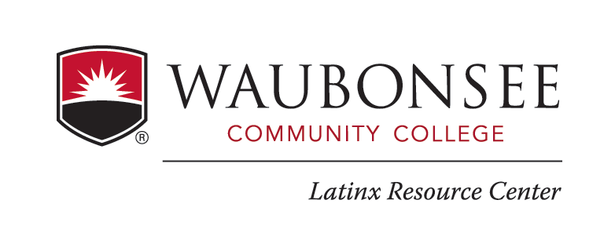
C.A.M.I.N.O.S Mentee Agreement Form
Name: _______________________________ | Email: ______________________________
Date: ________________________________  X-Number: ____________________________ | Phone #: ____________________________

As a mentee being a part of the C.A.M.I.N.O.S program, I ____________________ agree to the following.
- Meet with my Mentor twice a month
- Attend LRC retreats, conferences, workshops, and events when available
- Represent the LRC and C.AM.I.N.O.S Program professionally outside and inside Waubonsee Community College
- Communicate with Coordinators and Mentors if you have any questions

Signature: ____________________________________

